* **Setup**

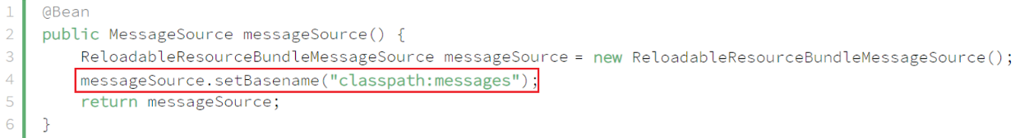

*MessageSource bean*

* **Using**
  + **LocaleContextHolder.getLocle(): get current locale**

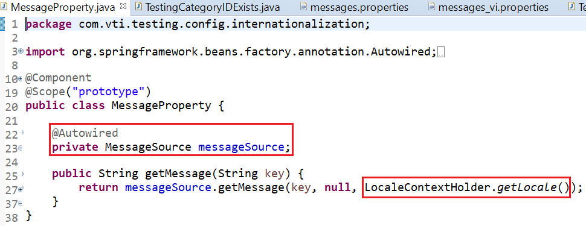

*MessageProperty Object*

* **Reference**